Day 4 Activity 2

Poster Reading

- Fill out the form based on the information in the poster.

Items about the these two transportations that are compared in the poster | 高铁 | 飞机
1.
2.
3.

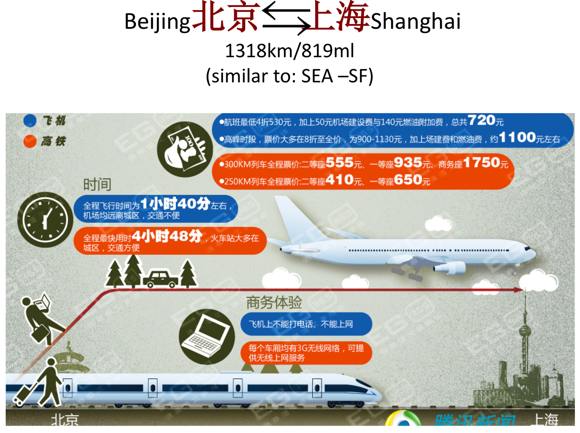

- There are three different scenarios listed in the following form. Choose a preferred transportation for each scenario based on the poster, using the pattern of 还是…吧. An example is given.
 | Scenario | Decision
example | 你的钱不多 | 我还是坐高铁吧。
1 | 你的时间很少
2 | 你要给老师打电话
3 | 你有钱，也得上网学习

- Use the following patterns to make two sentences based on the information in the poster.

- 离
- 又…又

